Website colour design document

Colors can influence individuals through psychological changes and they are combined by viewers with certain emotions and meanings. For website design, it is essential to get the browsers interested, to meet their information requirement. Thus selecting the right colors is very significant to create a website, because the colors designs are their first impression of the website. If browsers do not like the color palette, they will not stay on the site for a long time.

All the colors are divided into two categories: warm colors (red, orange and yellow) and cool colors (blue, purple and green).

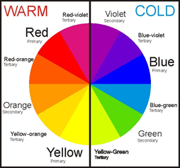

Red is associated with passion, danger, action, warning, adventure, heat, anger, and desire.



Orange is most commonly associated with comfort, warmth, creativity, fun, youth, enthusiasm, celebration and in website designs, this color is also associated with affordability.



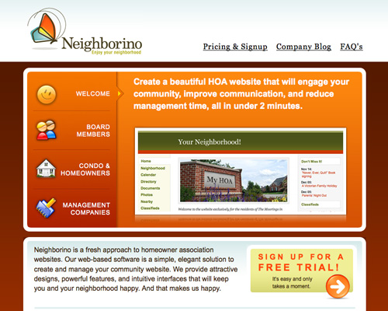

Yellow it’s an attention grabber, it suggests warmth and it’s associated with liveliness, energy, curiosity, joy, playfulness, optimism, sunlight, gold, idealism, but it can also create feelings of frustration, anger and illness. It’s a fatiguing color to the eye, that’s why you will never see a bright yellow website – but it’s a great color for important details or call to actions.



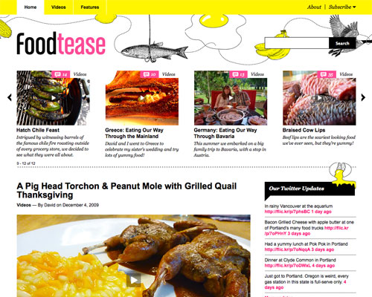

Blue is the color preferred by most people, especially by men. It is associated with calmness, serenity, peacefulness, security, stability, honour, trust, professionalism, success, seriousness and power.



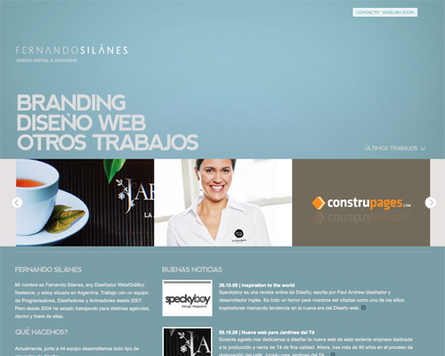

Purple has been traditionally associated with power, royalty, nobility, wealth, luxury, wisdom, spirituality, magic, mystery, dreams, fantasy as well as with ambiguity and uncertainty.



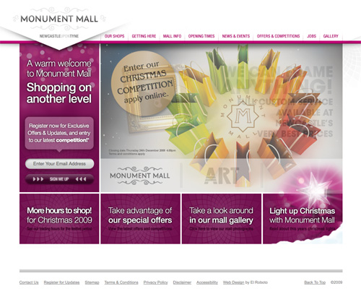

Pink is usually associated with tenderness, romance, love, youth, innocence, softness and it’s known to have a calming effect. The effects of this color may vary depending on the intensity of the color (strong, light, deep etc.)

Brown is a natural color, which is associated with relaxation, endurance, reliability, confidence, warmth, comfort, security and it’s considered to be conventional and sometimes sophisticated.



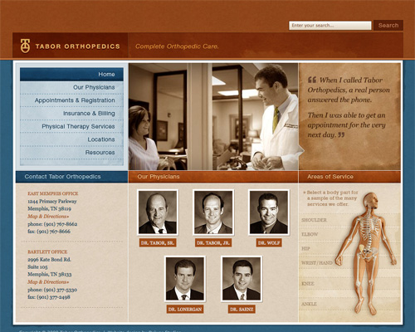

Grey is mostly associated with neutrality, indifference and it leaves the impression of seriousness and conservatism.



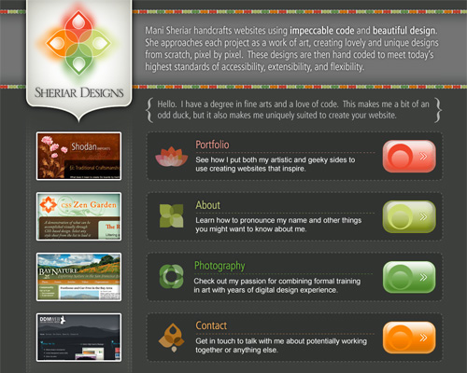

White is commonly associated with purity and innocence. It’s also associated with cleanliness, simplicity and newness.

Black is considered, especially in the design industry, a stylish and elegant color. It is also associated with sophistication, strength, mystery, depth, gloom, death, unhappiness, evil and sexuality.





Green is most often associated with nature, health, life, harmony, tranquillity, good luck, money, optimism, durability, freshness. It’s also a symbol of fertility, jealousy and it has a calming effect and it relieves stress.



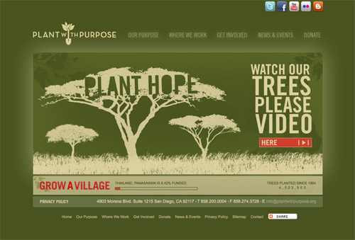

Reference:

Chapman, C. (2010, January 28) Color Theory for Designers, Part 1: The Meaning of Color Usability [Web log post]. Retrieved from <https://www.smashingmagazine.com/2010/01/color-theory-for-designers-part-1-the-meaning-of-color/>